Web Portal Design
Version: | 0.1
Author(s): | Aleksandar Tolev
Created: | 04/27/2009
Last modification:

Version | Date | Author(s) | Changes
0.1 | 04/26/2009 | Aleksandar Tolev
Contents
1. Introduction 1
2. Packages 2
2.1. De.decidr.ui.data 2
2.2. De.decidr.ui.controller 3
2.3. De.decidr.ui.view 4
3. Data Binding 5
4. Navigation 5
5. Portal view structure 6
6. Authentication and start page 6
7. Session Management 7
8. Secure connections 8
9. Different tenant view 8
9.1. Builder Pattern 9
9.1.1. UIBuilder 9
9.1.2. Concrete Builder 9
9.1.3. Director 9
9.1.4. Communication 10

Introduction
The following document describes the design of the web portal. In the “DecidR” application the web portal presents the user interface.
Some aspects of the design for example several design patterns, packages, data binding and navigation, session management, secured connections and the user interface’s structure will be described.

Packages

The whole web portal will be designed with the Model-View-Controller (MVC) pattern. To achieve the MVC pattern the web portal is divided into three packages. All packages are divided in subpackages to have a better overview.

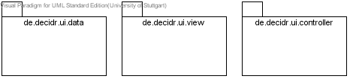

View packages

De.decidr.ui.data
In the data package the data for the web portal is stored. All containers which hold items for representing the data in the web portal are stored in this package. Additionally, the server side component of the modeling tool is stored in this package. The container classes implement thecom.vaadin.data.Container interface, so that these classes can use specific methods from the Vaadin framework container. Some container implement other container interfaces. For example the Container.Ordered interface. This interface is needed for deleting items from the table. The Container.Sortable interface makes the tables sortable by clicking on the column header.

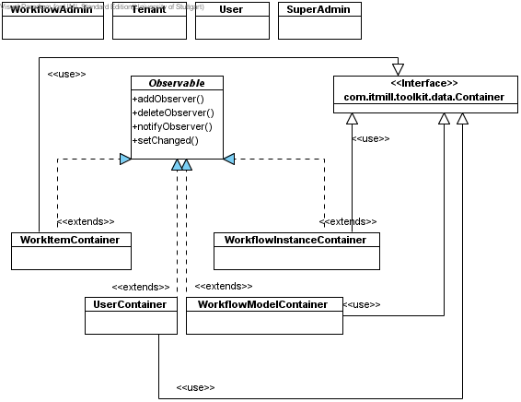

De.decidr.ui.data package

De.decidr.ui.controller
In the de.decidr.ui.controller package all action classes are stored. These action classes are used for managing the page flow and for handling actions. For more information have a look at Navigation. The last important class in this package is the UI director class. This class manages the view constructing. In the section Director you can find more information. Over the controller package all actions are handled. If the user interacts with the application and wants to change data, the controller is notified and triggers events to perform the action.

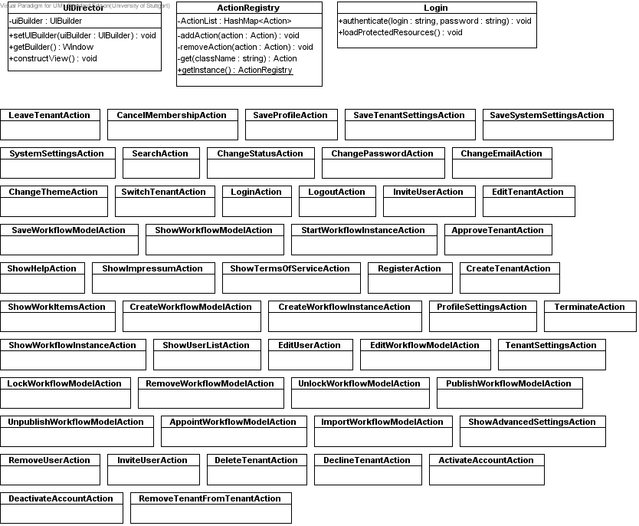
De.decidr.controller package

De.decidr.ui.view
The third package is the de.decidr.ui.view package. In this package all view components are stored. That means components like user menu, header, site notice window, help window, super admin menu and so on are stored in this package. All these components have an init() method where the specific components like buttons, labels, text fields and so on are initialized and added to the component. The particular view components are used for building the concrete view in the five different UI builder: UnregisteredUserViewBuilder, UserViewBuilder, TenantAdminViewBuilder, WorkflowAdminViewBuilder and SuperAdminViewBuilder. These five builder classes extend the UIBuilder class. For detailed description on how the UI builder and concrete builder work see Builder Pattern. The view components which represent a table or a list are stored in this package, too. The template view class builds a template where view components can be added or removed. It extends thecom.vaadin.ui.CustomComponent class. In this package also the custom component for the modeling tool is stored. This component represents the modeling tool which is implemented with Google Web Toolkit in a different project. So the modeling tool can be integrated in the web portal. The modeling tool insists of a client side and a server side component. In the data package the server side component is stored. In the view package the client side component is stored. Also, the Mainwidgetset.gwt.xml file is stored in this package. For more information have a look at Modeling Tool.

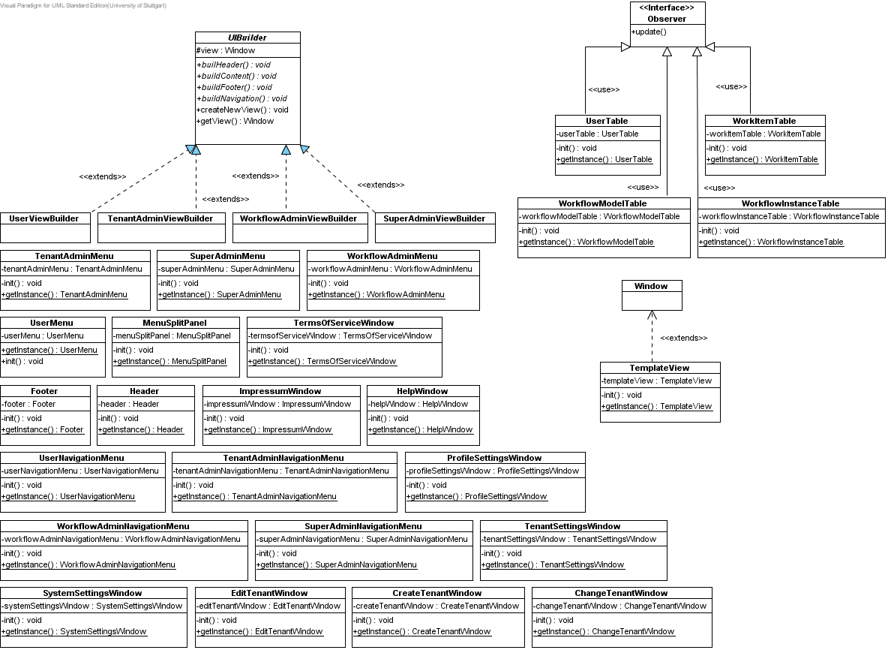
De.decidr.ui.view package

Modeling Tool

Client side component
The client side component of the modeling tool is called VModelingTool. It is located in the de.decidr.ui.view.client.ui package. The class extends the ModelingToolWidget from the Modeling Tool project, which is a composite widget from gwt and it implements the com.vaadin.terminal.gwt.client.Paintable interface. This interface provides updateFromUIDL(UIDL uidl, ApplicationConnection client). This method is necessary for sending the information from the server side to the client side. This method is called when the widget is instantiated and sets the dwdl and the user variable from the server. The class overrides the sendDWDLtoServer method from the ModelingToolWidget which updates all changes, which are made on the client side, and send them to the server. For more information read the VAADIN book

Server side component
The server side component of the modeling tool is called ModelingTool. It is located in the de.decidr.ui.data package. The class extends the AbstractComponent from the Vaadin framework. The paintContent method paints the modeling tool which is generated from the MainWidgetset. Two variables, dwdl and users, are added to the server side component, so they can be sent to the client and user these variables as information. When the user saves a dwdl the changeVariables(Object source, Map variables) method is called and delegates the created dwd to the model which stores it in the database. The getDwdl() method is used for getting a string representation of the dwdl which is stored as a Vaadin item in the table. The getUsers() method receives all users which belong to the current tenant and add them to a map. The key is the id and the value is the username. Then this map is converted to a xml string.

MainWidgetset
The MainWidgetset is located in de.decidr.ui.view.client and is generated from the Vaadin framework. This class builds the widget for the WebPortal from the client side component VModelingTool. The MainWidgetset.gwt.xml which is located in the de.decidr.ui.view package inherits some gwt libraries which are needed to compile the widgetset and defines the entry point which is the MainWidgetset. To compile the widgetset you have to launch the CompileWidgetset.launch file. This file calls the gwt compiler to compile the widget, so it can be integrated in the WebPortal and Vaadin can communicate with the widget. The launch file was generated from the Vaadin framework.

For more information on how the integration of GWT widgets works read the book of Vaadin.

Data Binding
In the web portal there will be several tables, trees or anything else displaying information like workflow models, user list, workflow instances, work items and so on. To show these items on the web portal we decided to use containers in which we can store such information (properties). These properties are stored in the model. The model offers item objects for holding data. These items will represent the information stored in the database. . These containers are connected with the corresponding components (table, trees, select). So the data is available through the containers where items can be extracted and placed in the view component to show the necessary information to the user. So the containers act as a controller in the web portal and delegate the information to the appropriate view components. Vaadin framework offers such containers, which can be filled with items. We will use the com.vaadin.data.Container interface and his methods for binding the data to the view components.

Navigation
The navigation in our “DecidR” application will not be a common page flow approach as it is usual for JSF or JSP applications. With the used Vaadin framework the navigation is handled like a normal desktop application. That means,there will be a swing-like approach. The flow is managed by action classes.
The user can navigate through our application via a navigation bar displayed on the left side of the “DecidR” web portal.

Portal view structure
As mentioned in Builder Pattern the view is constructed depending on the user’s role. Every role has a specific view. In our case we have five roles: unregistered user, user, workflow admin, tenant admin and super admin. Starting from the unregistered user every following role has more privileges and therefore more components which are visible for the user with the concerning role. For more information on how the view is constructed have a look at Builder Pattern.

Authentication and start page
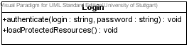

Login class

The user has to authenticate to the application to be able to perform any actions within the “DecidR” application. From a login window the user is able to enter his data (login and password). If the user submits, the method authenticate() from the login class is called. The login class is stored in de.decidr.ui.controller. This method takes the login and the password and sends them to the database via the user facade from the main model. There the login and password will be compared to the data which are stored on the database. If the comparison is successful the model sends a user object back to the web portal. The user’s id will be stored into the session, too. For more information see Session Management.

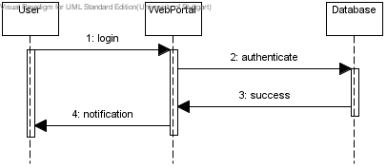

Login sequence diagram

Also the authenticate method calls the loadProtectedResources() method. This method contains the UI components which are protected for unregistered users. Depending on the user’s role which is contained in the received user object from the model the specific UI builder is set in the loadProtectedResouces() method and constructs the depending view. For more information see Director. Also the tenant view will be called to load the theme from the current tenant.

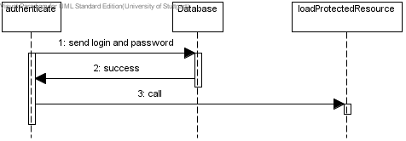

Login sequence diagram (methods)

Also the loadProtectedResources() method prevents an unregistered user to navigate through our application because the method is called only if the user is successfully authenticated to the application. If the authentication fails the method isn’t called and no UI builder is set, so that no view is built. The user remains on the start page where he can try to authenticate again. Also, the loadProtectedResources() method prevents an unregistered user to append names to the application URL to invoke specific web pages within the application. He will be redirected to the start page.

Session Management
As mentioned in the section Authentication and start page the user has to authenticate. To avoid frequently connections to the model some information has to be stored in the session. So this information is accessible application-wide because every session has its own application instance and can be reached immediately without connecting to the model. The session will be reached over the com.vaadin.service.ApplicationContext and com.vaadin.terminal.gwt.server.WebApplicationContext which is provided from the Vaadin framework. The session is provided by javax.servlet.http:
ApplicationContext ctx = getContext();
WebApplicationContext webCtx = (WebApplicationContext) ctx;
HttpSession session = webCtx.getHttpSession();
Creating session (code)

The session will be generated in the init() method from the main class. If the application is loaded the session is generated. Information like the user id, the current tenant id and the portal role are stored in the session via the session.setAttribute(String arg0, Object arg1) method. The user’s id is used for verification and for some functions of the facade which wants a user id as parameter. The current tenant id is used for allocating the current tenant to the authenticated user, so the specific settings, like color scheme, logo and description can be accessed via the tenant id. With the portal role the corresponding view is chosen, so that the user gets the right information displayed. The facades in the web portal a instantiated via the role stored in the session.

Secure connections
The application can use SSL for secure connections. There are no problems with the framework. The configuration has to be made on the tomcat server. There exists a configuration file named server.xml. This file is in the conf folder from the tomcat directory. First you have to create a certificate keystore.
If your tomcat runs on windows then execute the following command:
%JAVA_HOME%\bin\keytool –genkey –alias tomcat –keyalg RSA
If your tomcat runs on a unix system execute the following command:
$JAVA_HOME/bin/keytool –genkey –alias tomcat –keyalg RSA
And follow the instructions on the screen. You have to type in a password for the keystore.
In the next step you have to uncomment the “SSL HTTP/1.1 Connector” entry in $CATALINA_HOME/conf/server.xml and tweak as necessary.
The $CATALINA_HOME represents the home directory of your tomcat server.

Different tenant view
Every tenant has his own logo and custom style sheet of the page. If a user authenticates the appropriate logo and CSS will be received from the model, via the TenantView class. The TenantView class provides one method. It is called synchronize. In this method the associated logo, CSS and description from the current tenat are received from the model. If one of these components isn’t set at the receiving time the depending component is obtained from the default tenant. After that the components are stored locally to the specific VAADIN folder. For every tenant a folder is created with the tenant’s name. Inside this folder the CSS file is stored and another folder (img) is created. There the tenant’s logo is stored. The tenant view is used if the user authenticates to the application to load the tenant specific theme and if a user switches the tenant, then the theme of this tenant is loaded. The loading is realized by calling the com.vaadin.Application.setTheme(String name) method.Design Patterns

Builder Pattern

UIBuilder
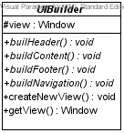
The builder pattern abstracts the steps of the view’s construction depending on the user’s role. There is an interface describing methods for creating components. In our case these components are the header, the content, the navigation bar and the footer. Also it is possible to create a new view. This new view is a window component which is provided by the Vaadin framework. In this window we can add our header, footer, content and navigation bar. To get the current window, where the components are shown we have the method getTemplateView().

UIBuilder class

Concrete Builder
The concrete builder extends the UI builder. Every class builds its own conrete header, concrete content, concrete footer and concrete navigation bar depending on what role the user has. For every user there must be one class which extends the UI builder interface.
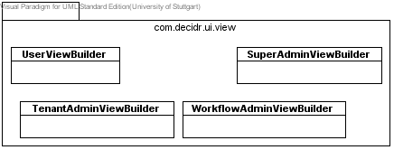

Concrete builder classes

Director
The director manages the correct sequence for the view creation. It receives a concrete builder and executes the appropriate methods. The setUIBuilder(UIBuilder uiBuilder) method sets one of the concrete UI builder described in Concrete Builder. So the corresponding UI builder is set and can build the view which is appropriate to the user. With getBuilder() it is possible to receive the current UI builder. The constructView() method allows the user to call the specific methods from the UI builder like buildHeader(), buildContent(), buildFooter() and buildNavigation() to construct the view he wants.

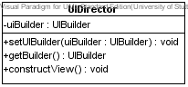

UIDirector class

Communication
These entire separate components act together and finally a constructed view depending on the user’s role is the result. The UI director sets the concrete builder. So it is determined what kind of view will be built. After that the concrete builder starts to build the header, footer, content and navigation bar. The UI director calls the build methods from the UI builder and constructs the view depending on the UI builder which was set before. In the following picture the communication is shown.

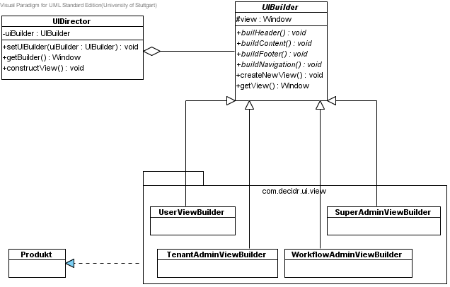

Communication within builder

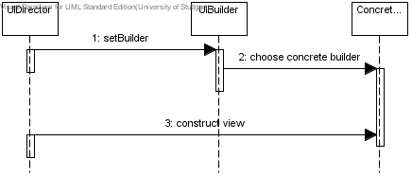

Builder sequence diagram

